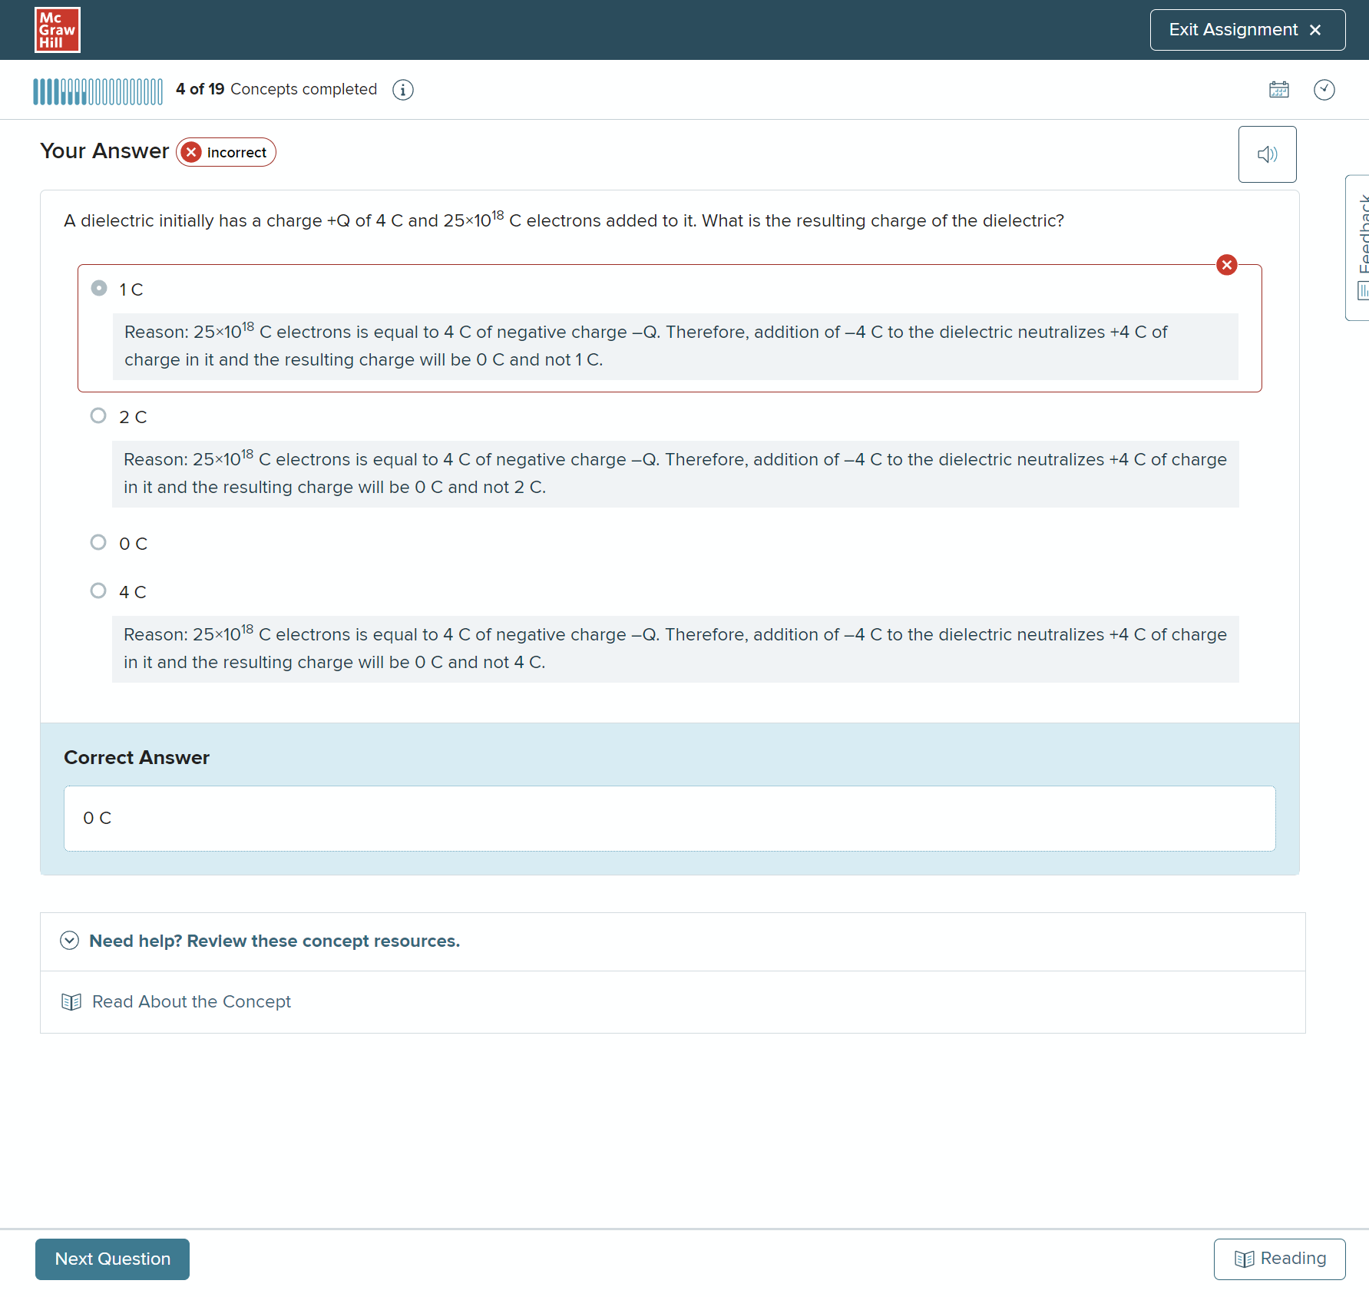

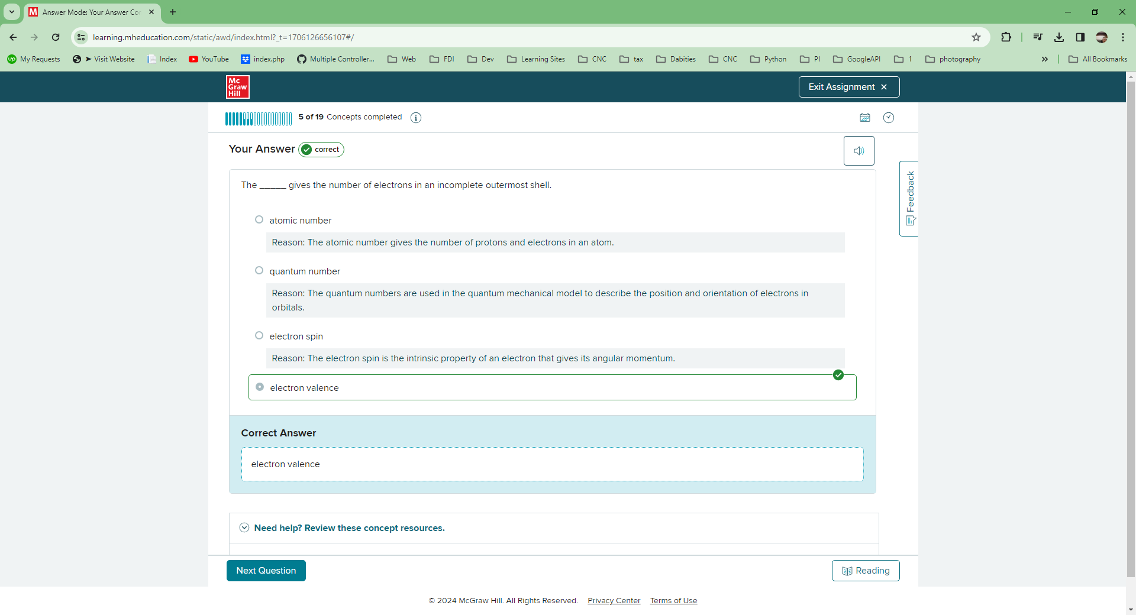

The _____ gives the number of electrons in an incomplete outermost shell.

Multiple choice question.



atomic number

Reason:

The atomic number gives the number of protons and electrons in an atom.



quantum number

Reason:

The quantum numbers are used in the quantum mechanical model to describe the position and orientation of electrons in orbitals.



electron spin

Reason:

The electron spin is the intrinsic property of an electron that gives its angular momentum.



electron valence

correct

**Correct Answer**

electron valence

The polarity of a proton is .

Multiple Choice QuestionYour Answer correct

The _____ are the basic particles of negative charge in an atom.

Multiple choice question.



electrons

correct



photons

Reason:

The photons do not have any charge.



protons

Reason:

The protons are the basic particles of positive charge in the atoms.



neutrons

Reason:

The neutrons are electrically neutral.

**Correct Answer**

Electrons

Your Answer correct

The amount of work required to move electrons between two charges depends on the _____.

Multiple choice question.



capacitance

Reason:

Capacitance is the ability of a system to store charge. It does not affect the work done required to move electrons between two charges.



inductance

Reason:

Inductance is the property of a conductor by which a change in current flowing through it creates an electromotive force. It does not affect the work done required to move electrons between two charges.



potential difference

correct



refractive index

Reason:

Refractive index is the ratio of the velocity of light in a vacuum to its velocity in a specified medium. It does not affect the work done required to move electrons between two charges.

**Correct Answer**

potential difference

Identify the effect on the particles when an electron and a proton are kept within range of each other's field of charge.

Multiple choice question.



The proton moves toward the electron.

Reason:

The proton is 1840 times heavier than the electron, so the electron moves toward the proton.



The electron moves toward the proton.

correct



The electron and the proton remain stationary.

Reason:

The electron and the proton are unlike charges. Hence, they attract each other and the electron moves toward the proton because the proton is heavier of the two particles.



The electron and the proton move away from each other.

Reason:

Like charges repel and move away from each other. As the electron and the proton are unlike charges, they attract each other and the electron moves toward the proton because the proton is heavier of the two particles.

**Correct Answer**

The electron moves toward the proton.

Your Answer correct

Identify the correct expression for calculating the voltage if Q represents the charge of the particle, W represents the amount of work done, T represents the time, and R represents the resistance.

Multiple choice question.



QT��

Reason:

The voltage is defined as the ratio of the work done (W) to the charge of the particle (Q), that is, *V =*WQ��. Here,QT�� is the expression for calculating current.



WQ��

correct



QW��

Reason:

The voltage is defined as the ratio of the work done (W) to the charge of the particle (Q), that is, *V =*WQ��. QW�� is the reciprocal of the voltage.



1R1�

Reason:

The voltage is defined as the ratio of the work done (W) to the charge of the particle (Q), that is, *V =*WQ��. Here, 1R1� is the expression for calculating conductance.

**Correct Answer**

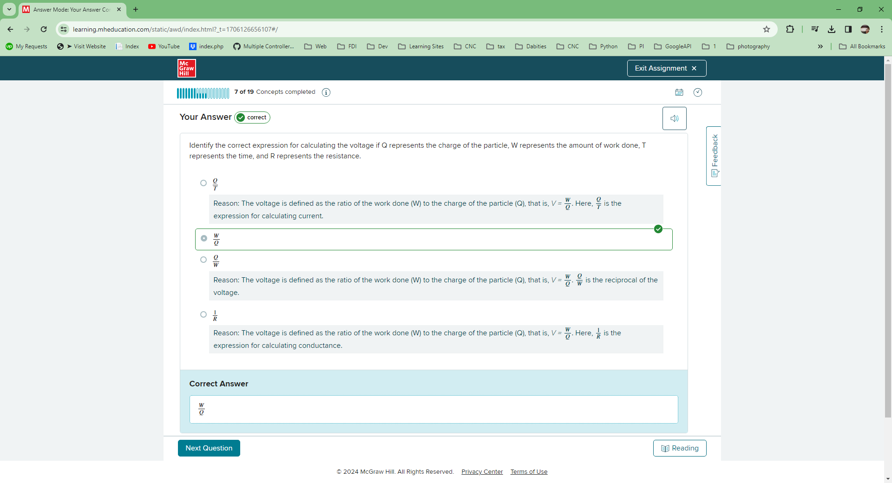

If two bodies have an equal amount of charge with the same polarity, they attract each other.

True false question.

True

Reason:

If two bodies have an equal amount of charge with the same polarity, they repel each other.

Falsecorrect

**Correct Answer**

False

The electric current between two points is caused by the _____.

Multiple choice question.



potential difference

correct



entropy

Reason:

The entropy is a measure of the number of specific ways in which a thermodynamic system may be arranged. It does not cause electric current between two points.



heat flux density

Reason:

Heat flux density is the amount of heat flowing through a surface per unit area. It does not cause electric current between two points.



refractive index

Reason:

Refractive index is the factor by which the speed of light is reduced in a medium. It does not cause electric current between two points.

**Correct Answer**

potential difference

Multiple Choice QuestionYour Answer correct

What is the term used for the condition when there is zero charge?

Multiple choice question.



Negative

Reason:

This condition exists when there is an excess of electrons.



Positive

Reason:

This condition exists when there is an excess of protons.



Neutral

correct



Ionized

Reason:

Any process by which electrically neutral atoms or molecules are converted to electrically charged atoms or molecules (ions).

**Correct Answer**

Neutral

Your Answer correct

The charge of a single electron is equal to _____.

Multiple choice question.



0.016×10–18 C

Reason:

This is not the charge of an electron.



1 C

Reason:

This is the charge of 6.25×1018 electrons.



0.16×10–18 C

correct



1.6×10–18 C

Reason:

This is the charge of ten protons.

**Correct Answer**

0.16×10–18 C

The value of the current is said to be one ampere, when the charge moves at the rate of _____ electrons flowing past a given point per second.

Multiple choice question.



6.25×1018

correct



1×1018

Reason:

The value of the current is said to be one ampere when the charge moves at the rate of 6.25×1018electrons flowing past a given point per second.



4×1018

Reason:

The value of the current is said to be one ampere when the charge moves at the rate of 6.25×1018 electrons flowing past a given point per second.



6.25×1012

Reason:

The value of the current is said to be one ampere when the charge moves at the rate of 6.25×1018electrons flowing past a given point per second.

**Correct Answer**

6.25×1018

An electron is placed in between two parallel sheets A and B. If sheet A has a charge of +1 C and Sheet B has a charge of +2 C, what is the effect on the electron?

Multiple choice question.



The electron moves toward sheet A.

Reason:

Sheet B has greater positive charge and, therefore, has a greater force of attraction. So, the electron moves toward sheet B.



The electron moves toward sheet B.

correct



The electron remains stationary.

Reason:

The electron does not remain stationary because there is a net force acting upon it.



The electron moves in the direction parallel to the faces of the sheets.

Reason:

The electron moves in the direction of the sheet B because the net force acting upon it is in that direction.

**Correct Answer**

The electron moves toward sheet B.

Multiple Choice QuestionYour Answer correct

What is the unit for measuring resistance?

Multiple choice question.



Faraday

Reason:

This is the unit for measuring capacitance.



Siemens

Reason:

This is the unit for measuring conductance.



Henry

Reason:

This is the unit for measuring inductance.



Ohm

correct

**Correct Answer**

Ohm

The _____ is a measure of the amount of work or energy needed to move an electric charge.

Multiple choice question.



watt

Reason:

The watt is a measure of power.



volt

correct



ampere

Reason:

The ampere is a measure of current.



coulomb

Reason:

The coulomb is a measure of charge.

**Correct Answer**

volt

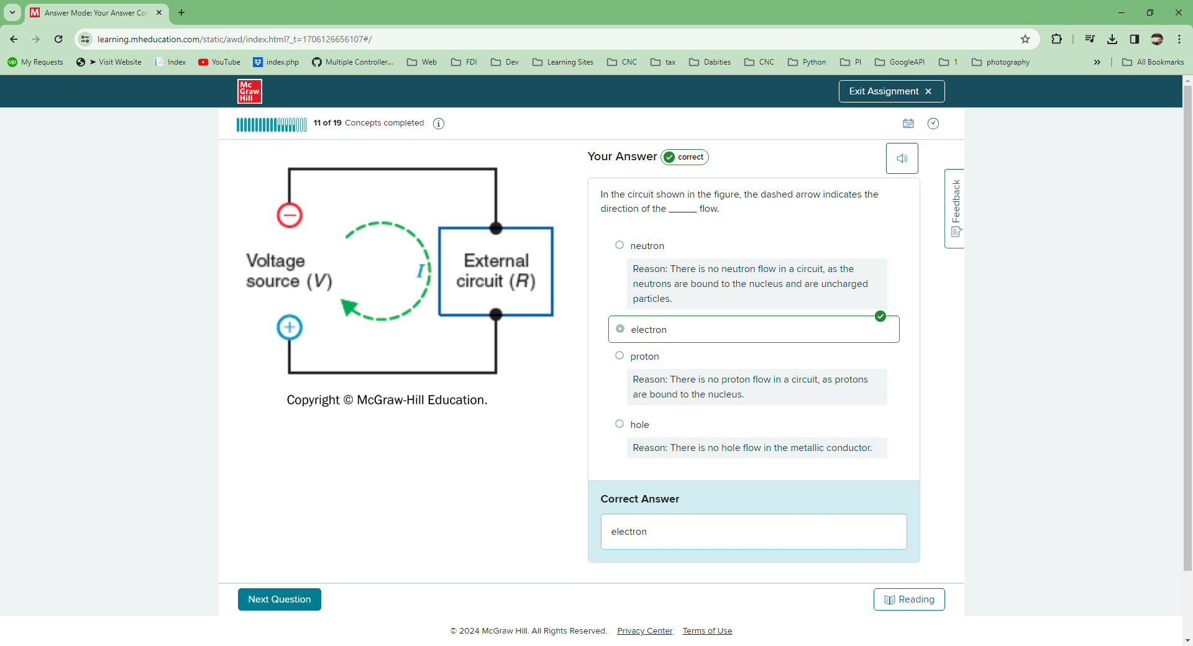

Your Answer correct

In the circuit shown in the figure, the dashed arrow indicates the direction of the _____ flow.

Multiple choice question.



neutron

Reason:

There is no neutron flow in a circuit, as the neutrons are bound to the nucleus and are uncharged particles.



electron

correct



proton

Reason:

There is no proton flow in a circuit, as protons are bound to the nucleus.



hole

Reason:

There is no hole flow in the metallic conductor.

**Correct Answer**

electron

Multiple Choice QuestionYour Answer correct

When the potential difference between two charges forces a third charge to move, the charge in motion is called a(n) _____.

Multiple choice question.



capacitance

Reason:

Capacitance is the ability of a system to store charge.



electric current

correct



electro-motive force

Reason:

Electro-motive force is the difference in potential that tends to give rise to an electric current.



voltage

Reason:

Voltage is the potential difference between two points.

**Correct Answer**

electric current

A motion of positive charges, in the opposite direction from electron flow, is considered _____.

Multiple choice question.



conventional voltage

Reason:

The motion of charges is called current and not voltage.



conventional current

correct



feedback voltage

Reason:

The motion of charges is called current and not voltage. The feedback voltage is the voltage across the feedback path in a circuit.



emitter current

Reason:

The current flowing out of the emitter region of transistor is called emitter current.

**Correct Answer**

conventional current

A dielectric initially has a charge +Q of 4 C and 25×1018 Celectrons added to it. What is the resulting charge of the dielectric?

Multiple choice question.



4 C

Reason:

25×1018 C electrons is equal to 4 C of negative charge –Q. Therefore, addition of –4 C to the dielectric neutralizes +4 C of charge in it and the resulting charge will be 0 C and not 4 C.



1C

Reason:

25×1018 C electrons is equal to 4 C of negative charge –Q. Therefore, addition of –4 C to the dielectric neutralizes +4 C of charge in it and the resulting charge will be 0 C and not 1 C.



2 C

Reason:

25×1018 C electrons is equal to 4 C of negative charge –Q. Therefore, addition of –4 C to the dielectric neutralizes +4 C of charge in it and the resulting charge will be 0 C and not 2 C.



0 C

correct

**Correct Answer**

0 C

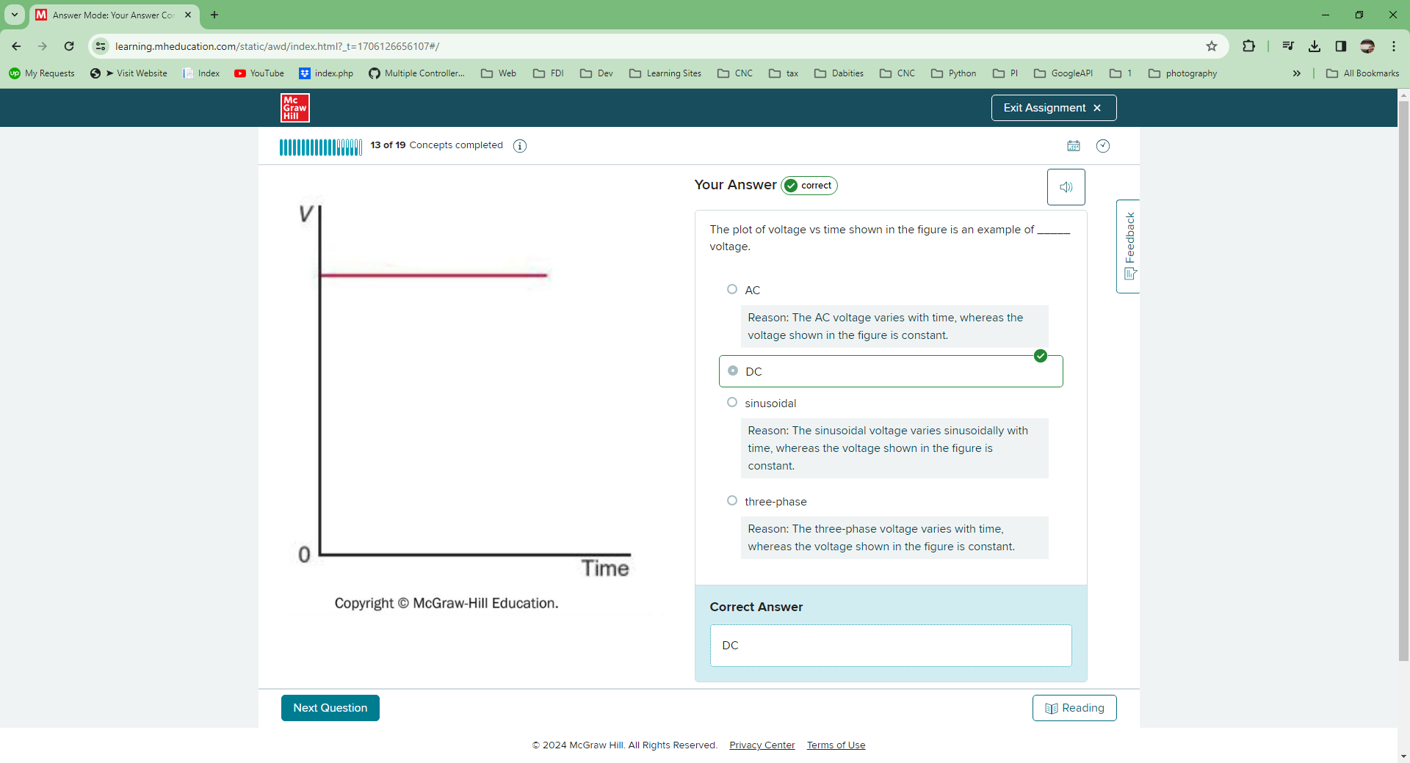

The _____ is a measure of how intense or concentrated the electron flow is.

Multiple choice question.



current

correct



voltage

Reason:

Voltage is the measure of the potential difference between any two points.



power

Reason:

Power is defined as the rate of work done.



resistance

Reason:

Resistance is the measure of the conductor to impede the flow of current.

**Correct Answer**

Current

## Your Answer correct

Identify the characteristics of AC voltage.

Multiple select question.



The voltage from an AC voltage source has zero frequency.

Reason:

The AC voltage has nonzero frequency.



It is the voltage available at the output of a rotary generator.

correct



It varies in magnitude and reverses in polarity periodically.

correct



AC voltage can be stepped up or down with a transformer.

correct

## Correct Answer

* It is the voltage available at the output of a rotary generator.
* It varies in magnitude and reverses in polarity periodically.
* AC voltage can be stepped up or down with a transformer.



Identify the definition for a resistance of one ohm.

Multiple choice question.



A resistance that develops 0.036 calorie of heat when one ampere of current flows through it for one second has one ohm of opposition.

Reason:

A resistance that develops 0.24 calorie of heat when one ampere of current flows through it for one second has one ohm of opposition.



A resistance that develops 0.24 calorie of heat when one ampere of current flows through it for one second has one ohm of opposition.

correct



A resistance that develops 0.36 calorie of heat when one ampere of current flows through it for one second has one ohm of opposition.

Reason:

A resistance that develops 0.24 calorie of heat when one ampere of current flows through it for one second has one ohm of opposition.



A resistance that develops 0.024 calorie of heat when one ampere of current flows through it for one second has one ohm of opposition.

Reason:

A resistance that develops 0.24 calorie of heat when one ampere of current flows through it for one second has one ohm of opposition.

**Correct Answer**

A resistance that develops 0.24 calorie of heat when one ampere of current flows through it for one second has one ohm of opposition.

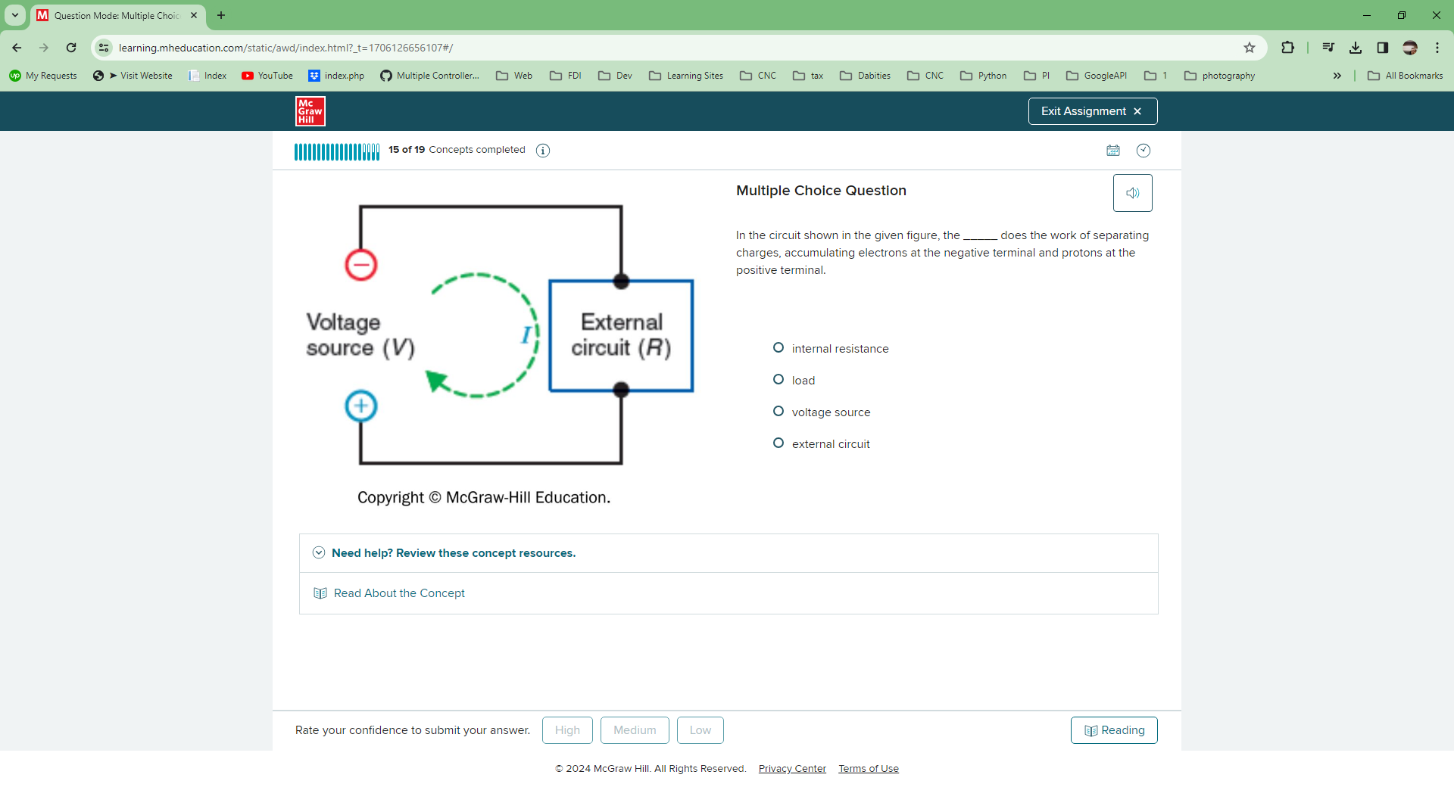

In the circuit shown in the given figure, the _____ does the work of separating charges, accumulating electrons at the negative terminal and protons at the positive terminal.

Multiple choice question.



internal resistance

Reason:

The internal resistance impedes the flow of current out of a battery.



load

Reason:

The voltage source creates potential difference while the load consumes power from the battery.



voltage source

correct



external circuit

Reason:

The voltage source separates the charges and not the external circuit.

**Correct Answer**

voltage source

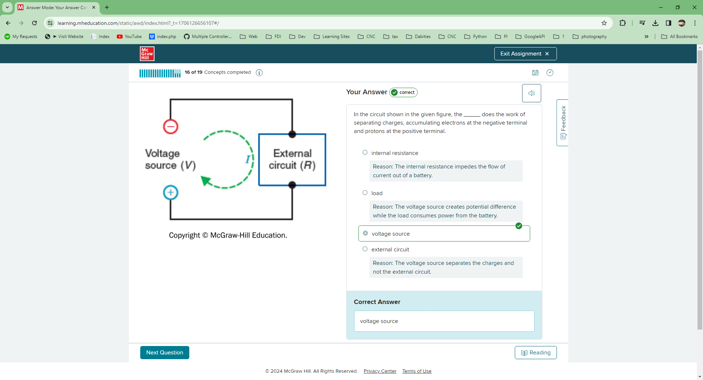

Multiple Choice QuestionYour Answer correct

In the given figure, the solid arrow indicates the direction of the _____ current.

Multiple choice question.



neutron

Reason:

There is no neutron current in a circuit, as the neurons are bound to the nucleus.



conventional

correct



electron

Reason:

The electron current flows in the direction opposite to the direction of the solid arrow.



proton

Reason:

There is no proton current in a circuit, as the protons are bound to the nucleus.

**Correct Answer**

conventional

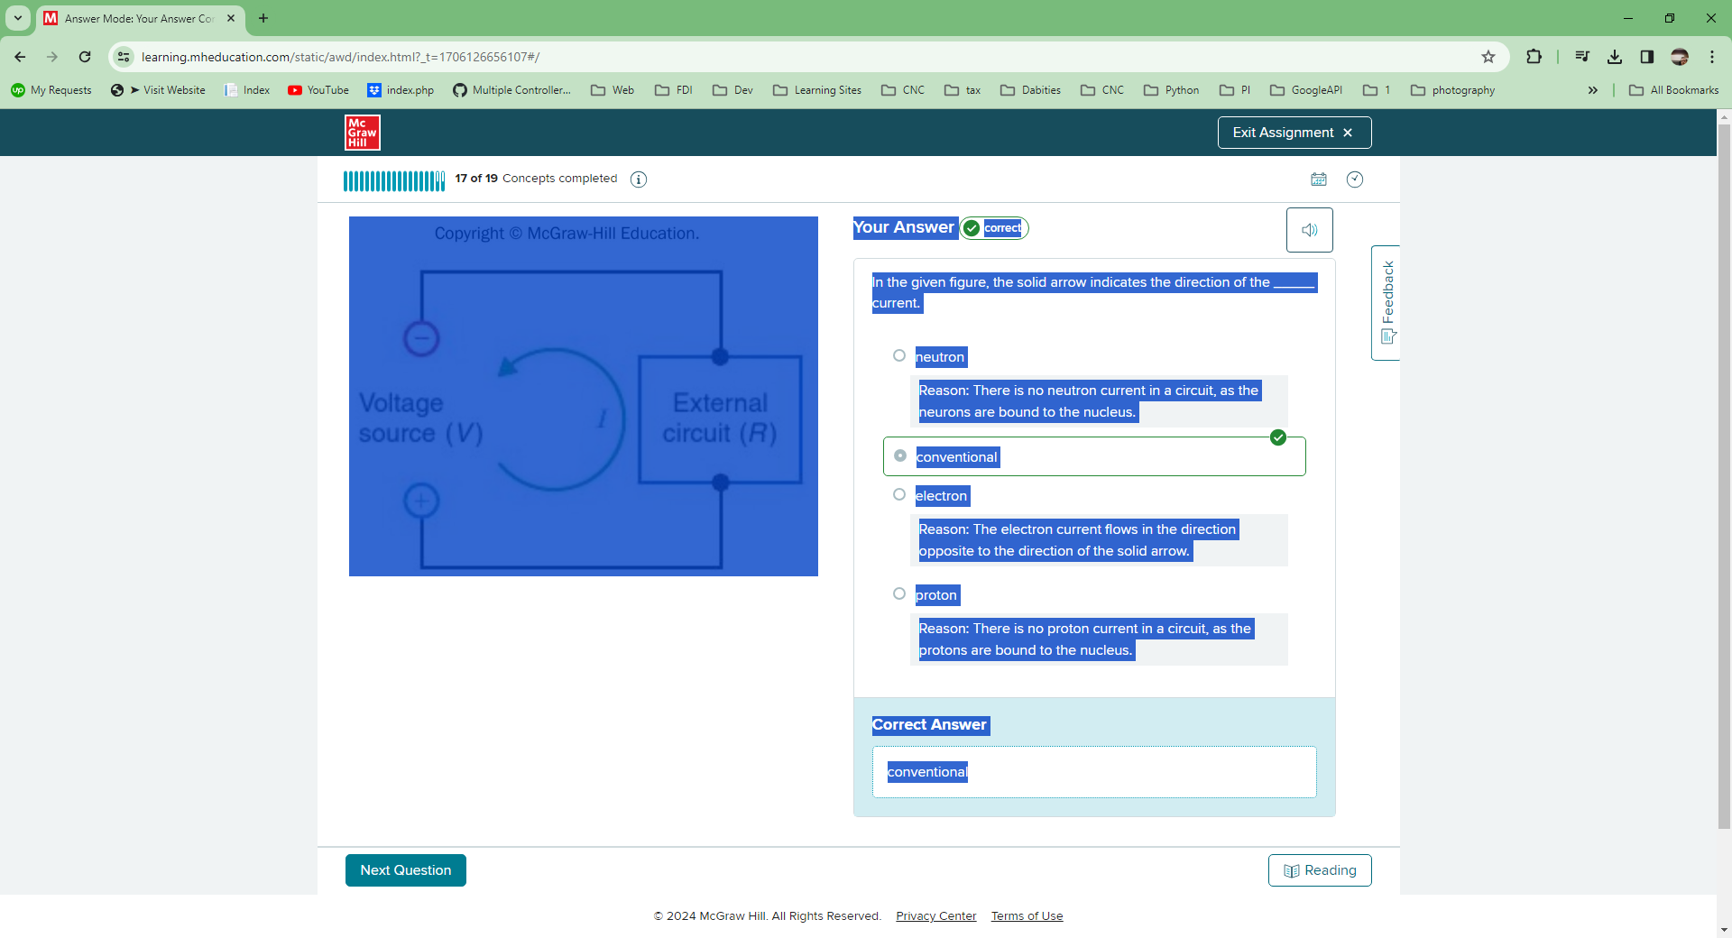

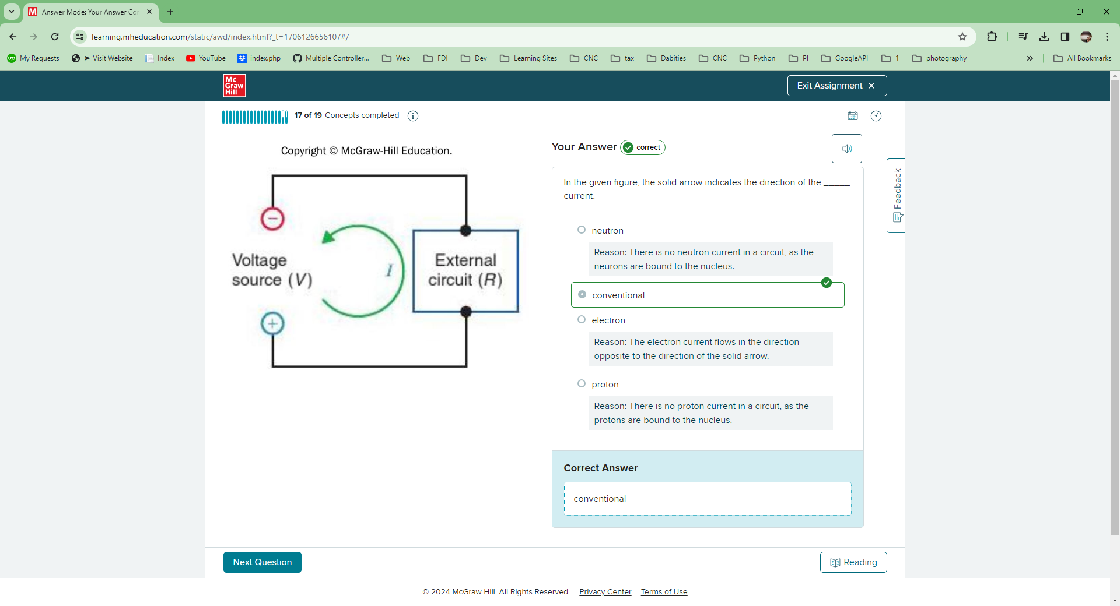

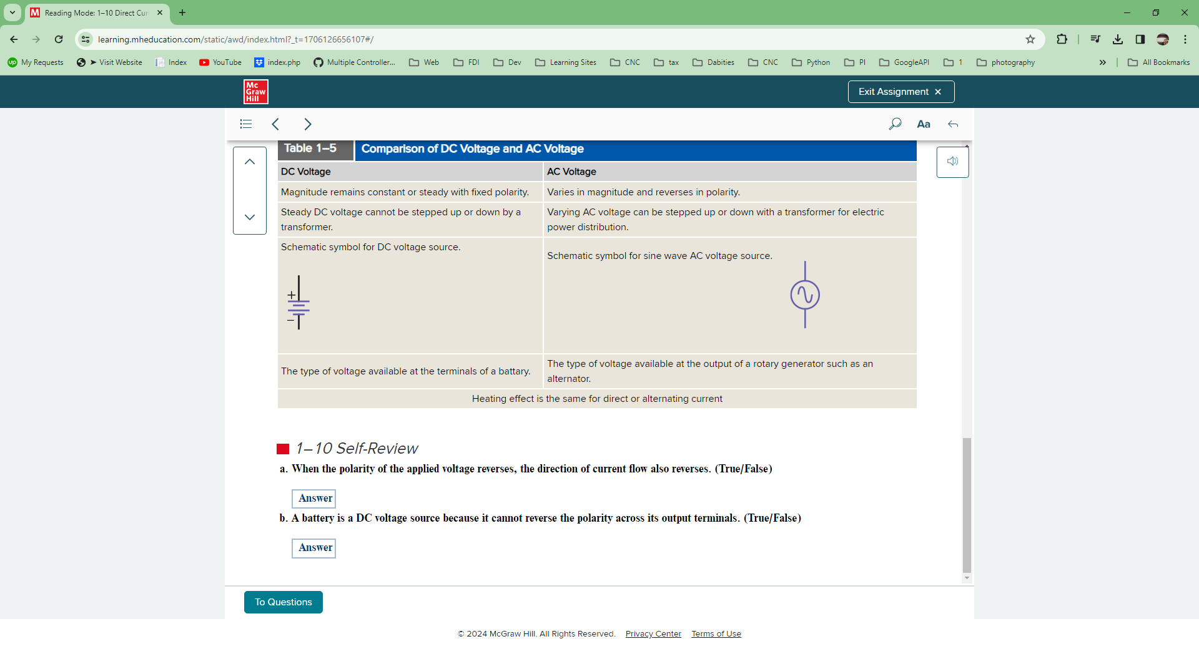

## Your Answer correct

Identify the statements that are true of DC voltage.

Multiple select question.



The voltage from a DC source is sinusoidal in nature.

Reason:

The DC voltage is not sinusoidal in nature because the DC voltage does not vary with time.



DC voltage magnitude remains constant with fixed polarity.

correct



The DC voltage cannot be stepped up or down by a transformer.

correct



It is the type of voltage available at the terminals of a battery.

correct

## Correct Answer

* DC voltage magnitude remains constant with fixed polarity.
* The DC voltage cannot be stepped up or down by a transformer.
* It is the type of voltage available at the terminals of a battery.

